# Website Evaluation

The website evaluation was done to examine how useful, usable and effective the website was. Usefulness is whether students feel that they have a need for this software. This is important because a significant part of the application is that the users can submit content. If the users find this useful they will use our application more.

Usability is how well participants can navigate the website and to carry out their goals with the website. If the website is very usable it will mean that users will find that they can quickly get what they want done without frustration or confusion. If the website is very usable then users will be more likely to come back and use it again.

Finally the effectiveness is analysed. The effectiveness is how well the website does the job it is supposed to do. Effectiveness is different from usability because effectiveness measures whether the website does what it is supposed to and usability measures whether users can do this easily. The job of the website in this case is to allow users to submit content to the balloon system in the aim of sharing content with others.

### How the website was evaluated

To evaluate the website a questionnaire was created with which the participants could fill out after trying to submit a balloon with the website. The participants were usually people who have used the balloon news program but as the questionnaire was put online, some people who answered it may not have used it before. All participants had to have been members of the MACS network as this was needed for a login.

The questionnaire has 7 questions which cover the subjects above. It was made short as the other two questionnaires were quite long and it was decided not to take up too much time for the participant.

The questionnaire starts off by trying to asses the person who is answering the questionnaire. Have they used the balloon news program and do they share content. The first is a control question and the second is trying to evaluate the usefulness of this website. The next five questions are all on the website, asking the user how efficient and effective it was.

### Analysing the Results

Question 1:

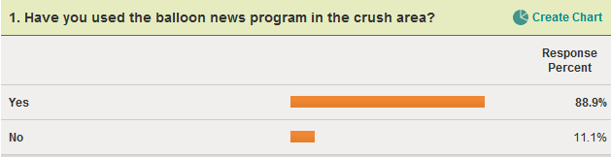The results show that most people who filled out the questionnaire had used the balloon news before. This was due to most of the responses being after the participant had played around with the Balloon News game.

Question 2: 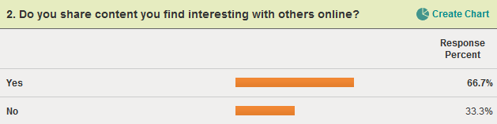

From this it can be seen that the number of people who share content online was high. However a third of the respondents did not share online content. As two thirds of the respondents answers yes to this question it is fair to assume that there is a market for allowing students to share content with each other and that the Balloon News program would be a good tool for that.

Question 3: 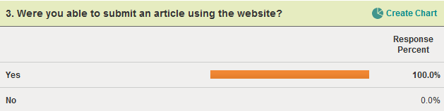

This data shows that the purpose of the site was fulfilled in all cases. Every participant in out questionnaire who tried to submit an article succeeded.

Question 4:

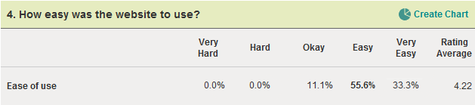

From this multiple choice answer it can be seen that the website was found easy to use. No participants said that the website was difficult. However the participants were not as numerous at saying that it was very easy.

Question 5:

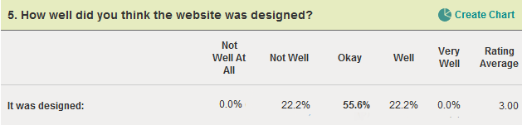

The response from this question on design was not as high as for the ease of use. However it was not overly negative either which suggests that while participants were not in favour of the design, they did not dislike it to an extreme. This does suggest though that the design should be improved.

Question 6:

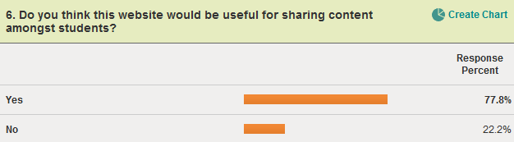

The response to this question gives an impression of how that targeted consumer of the application feels about its usefulness. From this it can be found that participants did think that the website would be useful as over three quarters of respondents said that it would be useful.

Question 7:

This was an open feedback question. The participants were asked whether they wanted any extra features. Most of the comments centred on the submissions of images with the post. One participant commented that “It was annoying to have to submit an image”. Another suggested that a URL could be given instead.

Other feedback was on the design. Participants didn’t think that the design was brilliant and one person commented that it “looks like it was done by a first year high school student!”.

One of the other extra features that were asked for was to be able to see where a submitted piece of content was on the screens. This could be considered for future development.

### Conclusion

The original aim of the questionnaire was to assess the usability, usefulness and effectiveness of the website consumers will use to submit content to the screens.

In terms of usability the results were very positive. All users found that they could submit an article, which indicates that the usability is not stopping users from completing their objectives. Participants also fed back that the website was generally easy to use with 56% saying it was easy to use and 33% saying it was very easy to use. This indicates very strongly that the usability of the website is high. One area which is not as positive is the design. A good design makes the usability easier. While the ease of use was rated as high the design was not rated as high. Therefore it could be that if the design was improved the usability could also be improved.

The second factor was usefulness. Usefulness is important as if the website is not useful then no one will use it and the content on the screens will not be as relevant to students. Usefulness was assessed through asking participants whether they shared content online and how useful they felt the website was. Sixty-seven per cent of respondents revealed that they share content online. If participants share content online then they are more likely to share content on our system as our system is also online and any social factors that may make someone not share content online with others will not apply to them as they already do it. Participants also responded that they thought the website would be useful with 78% saying so.

The final factor being analysed was effectiveness. The goal of the website was to give students a way of submitting content to be displayed on the Balloon News screens. This was analysed through asking participants whether they could complete the objective. 100% of participants manage to submit an article to the screens so the website is effective at what it is designed for.

In summery the website was a success at allowing users to submit content to screens and participants thought it was a good idea. However the design could be given an overhaul and the process could probably be made slicker. An idea for the future may be to link the Balloon News website with Facebook or other online content sharing websites and allow users to add content to the balloon news feed by “liking” an article. This would take some research into implementations but if it could be done then it simplifies the process and it integrates the system into something users are already familiar with and use every day, thereby increasing the market as it were.